Business Plan for Extension of Gynaecology CATS -

Primary Care Based Colposcopy Service

Introduction

Verulam Gynaecology Clinical Assessment and Treatment Service is a primary care based gynaecology service providing care to patients in St. Albans and Harpenden registered with STAHCOM member practices.

The CATS is provided by Verulam Medical Group, based at Colney Medical Centre in St. Albans. The service has been running successfully now since mid-July 2007, and has enjoyed a very high retention rate (70-80%) of patients within the service. Quality and training are core features of the service and the GPSIs (from 3 different practices) work alongside the Consultant Gynaecologists in delivering care. All 3 GPSIs are also studying for their postgraduate diplomas in gynaecology.

Primary Care Based Colposcopy Service

It is proposed to extend the service into the assessment and management of abnormal smears. Currently, all female patients are offered cervical smears through their GP practice according to the National Health Service Cervical Screening Programme. These smears are usually taken by a Practice Nurse and sent to West Herts Hospital Pathology Department for reporting. The vast majority of smears are reported as normal and the GP notified that no further action is necessary. Some smears are reported as abnormal. Some of these may simply require a repeat smear by the Practice Nurse at a specified time interval.

Others require intervention, and currently a letter is sent by West Herts Hospitals Pathology Department to the patient’s GP that referral to a Colposcopist is required. The GP will then refer the patient into a hospital based colposcopy service. The patient will be seen initially for a diagnostic colposcopy. Low grade abnormalities will be followed up with 6 monthly colposcopies/biopsies, resulting in discharge if everything is felt to be satisfactory at follow up. High grade abnormalities require a biopsy and probably treatment. Follow up with regular smears is then required.

There is a significant risk that delays and omissions can occur within the current local system of the Hospital lab having to inform the GP of an abnormal result, and the GP then having to make a formal referral into a Hospital based colposcopy service. Some areas nationally have moved to a direct referral system, with the GP being informed of an abnormal smear, and the hospital lab simply referring directly into the colposcopy service.

Advantages of a Primary Care Based Service

i) Improved Clinical Governance through Direct Referral

It is proposed to move to a direct referral system within the STAHCOM area, with all abnormal smears being sent directly into the Gynaecology CATS. While direct referral will be to the CATS Service all patients requiring colposcopy will be offered choice and will be free to discuss and choose alternative providers with their GP. This is a national requirement. The CATS would initiate diagnosis and treatment after informing the patient’s GP of the abnormal smear. GPs would be kept up-dated during management and then informed of discharge from the service. This would significantly reduce the risk of missed referrals by GPs as well as reduce GP workload.

ii) Improved Service Quality - Reduced waiting times

Waiting times will be significantly better than the current hospital-based services.

Both the St. Albans City Hospital and Luton & Dunstable Hospital services are failing the NHSCSP standard of seeing 90% of patients with moderate dyskaryosis or worse changes on smear within 4 weeks. 61% are seen within 4 weeks at SACH and only 15% at Luton. Both services are also failing the NHSCSP standard of seeing 90% of patients for their first appointment within 8 weeks. SACH sees just over 80% and Luton just over 50%.

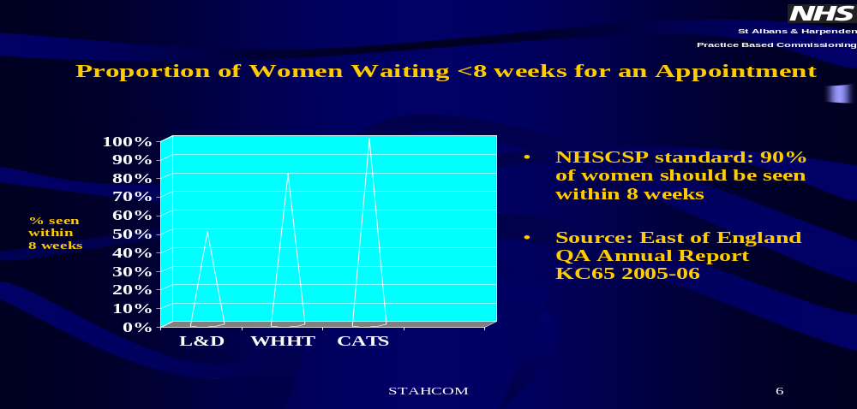

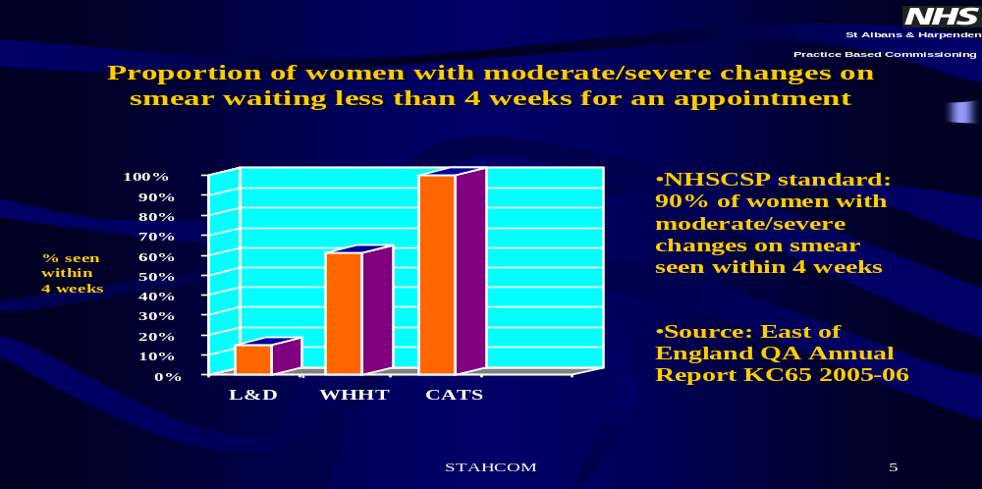

Both services are also failing the NHSCSP standard of 90% of women receiving their result within 4 weeks and 100% within 8 weeks. Only 30% of patients received their result within 4 weeks at SACH and less than 20% at Luton. Just over 90% received their results within 8w at SACH and less than 70% at Luton. (Data from East of England Screening QA Annual Report 2005-2006).
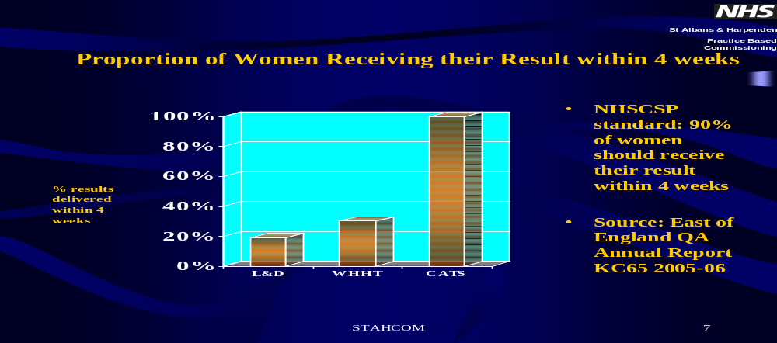

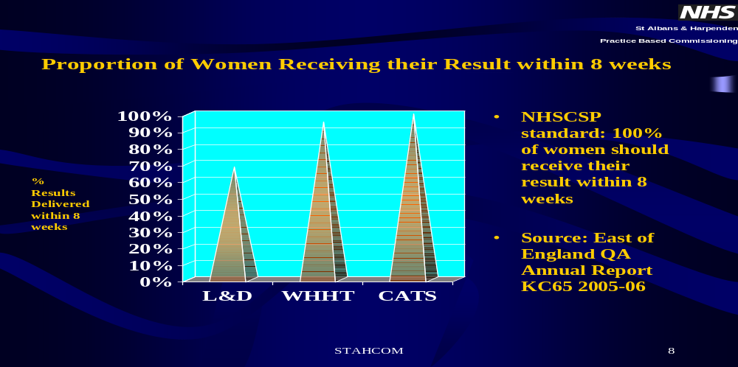
The primary care based service would aim to meet the NHSCSP standards of seeing at least 90% of patients within 4 weeks for moderate dyskaryosis and 90% of all patients within 8 weeks, and of communicating with 90% of patients within 4 weeks and all patients within 8 weeks. Studies have shown that the level of anxiety patients experience with an abnormal smear finding is greater than that experienced the night before a triple artery bypass operation. Thus, by reducing waiting times and anxiety for patients with abnormal smears significantly, a superior service can be offered and un-necessary worrying reduced.

iii) Cost savings
There would be an expected time lag in generating savings of about 1-2 months as this is the amount of time the patients wait for treatment and patients already in the system will be worked through by secondary care and the alternative service for CATs will then kick in. The CATS service would expect to receive 90% rising to 95% of all abnormal smears, accounting for patient choice.

The Gynaecology CATS aims to carry out colposcopy assessment and treatment at less than the National Tariff price, which will deliver a significant cost saving to STAHCOM (and West Hertfordshire PCT).

Current Activity for STAHCOM patients: 520 new referrals
Current cost based on PBR for STAHCOM pts: £879,625
Estimated CATS cost for STAHCOM pts: £755,362

Estimated savings in year one against tariff : £75,202 (%saving 15.03%)
Tarrif price in 1st year incl MFF @22% £610,619
Estimated savings in year one against tariff+MFF £185,314 (%saving 30.35%)

Estimated savings in year two against tariff: £90,940
Tarrif price incl MFF @22% £1,007,554
Estimated savings in year two against tariff+MFF £272,630 (%saving27.06%)

Estimated savings in year three against tariff: £124,264
Tarrif price incl MFF@22% £1,073,143
Estimated savings in year three against tariff+MFF £317,781 (%saving29.61%)

iv) Service redesign

This proposal will safely and appropriately shift work from the acute sector into the primary care sector. This is in line with current Department of Health policy. It also supports the outcomes of the Hertfordshire PCTs’ Acute Services Review and STAHCOM’s own Business Plan, which states on page 5 that “the goal is therefore to move as much activity as possible from an emergency and acute setting to intermediate and primary care”.

Quality Assurance & Networks

All colposcopy services have to be certified by the Regional Quality Assurance Reference Centre (QARC). The role of the QARC in each region is to monitor and maintain minimum standards of service, performance and quality across the cervical screening programme, and to promote and lead the continual pursuit of excellence in these services. The CATS has been visited informally by an assessor, who is satisfied with the proposal at this stage. Once the decision has been taken to proceed, a formal visit will be organised to gain formal approval and certification from the appropriate Regional QARC.
The primary care based colposcopy service will be Consultant-led and all consultants in the area will be offered the opportunity to apply to be considered to participate in the provision of this service and will be selected on the grounds of their clinical expertise and their ability to work within a primary care led service which requires flexibility, commitment and a patient centred approach. All Consultants will be certificated through the British Society for Colposcopy and Cervical Pathology (BSCCP) and the Royal College of Obstetricians and Gynaecologists (RCOG). It is proposed to train a GPSI and/or Nurse in colposcopy, who would be valuable on-going resources to STAHCOM, and would be able to work independently within the service once certificated.

The service will adhere to the requirements laid down by the NHS Cancer Screening Programme in the document “Colposcopy and Programme Management – Guidelines for the NHS Cervical Screening Programme.” It will link with the Watford General Hospital Gynaecological Cancer Unit and hence the Mount Vernon Cancer Centre Network, thus streamlining care for cancer patients.

The service will be situated in London Colney initially and for the foreseeable future. This has excellent public transport access from St Albans and Harpenden, offers free parking and is situated in one of the more deprived parts of the area thus helping to improve access for women who are more likely to need the service and thus help reduce health inequalities. Regular patient surveys will be carried out to monitor patient satisfaction with the primary care based service, and these will be reported to STAHCOM, the group responsible for commissioning this service.

Conclusion

This proposal is supported by the STAHCOM Board and LMG Council. It has been prepared in conjunction with:

- Katrina Power, PCT PBC Support Manager to STAHCOM
- Suzanne Novak, Assistant Director of PBC, West Herts PCT
- Mo Girach, Chief Executive Officer of STAHCOM.
- Tad Woroniecki, Asst Director of Finance, Herts PCTs
- David Hodson, Information Manager, Business Development
- Dr. Jane Halpin, Director of Public Health, Herts PCTs
- Dr. Steve Laitner, Public Health Consultant to STAHCOM & GP
- Clive Appleby, Asst Director of Corporate Services, Herts PCTs
- John Streeton, Senior Buyer, HSMC
- Beverly Flowers, West Herts PCT Director of Commissioning
- Sue Marsden, PCT Screning Adviser

This proposal is a natural extension of the Gynaecology CATS, and by establishing this service we are implementing a significant shift of gynaecology treatment into primary care in line with the ASR and offering more choice of provider to local patients. There will be an impact on activity levels at WHHT but they will still have sufficiently high activity levels to be viable as a Unit and would be able to continue to run the colposcopy service at SACH if the gynaecologists work together as a team across the Trust as we would expect.

The PBC Support Team in West Herts is working with us, under the guidance of the Director of Finance, to negotiate the terms and conditions of the contract extension so that it secures best value for the PCT but also enables a new service to be established and to share the risks of change with both parties. This team will work closely with us in identifying the costs and risks.

This proposal will significantly improve the service offered to STAHCOM patients and GPs. It will generate significant cost-savings, allowing freed up resources to be reinvested by STAHCOM and will maintain links with the local Cancer Network. We are looking for an agreement from the PBC Governance Committee to proceed, with a proposed start date for the service of August 2008.

Meeting assessment criteria
1 | Evidence based clinical effectiveness and priorities | This service will be officially accredited by the Regional Quality Assurance and Reference Centre (QARC). All Consultants will be accredited by the British Society for Colposcopy and Cervical Pathology (BSCCP) and the Royal College of Obstericians and Gynaecologists (RCOG). The service will adhere to the requirements laid down by the NHS Cancer Screening Programme in the document “Colposcopy and Programme Management – Guidelines for the NHS Cervical Screening Programme .
2 | Clinical safety, quality & governance | This will improve waiting times and ensure that the national NHSCSP standard of seeing 90% of patients within 4 weeks for moderate/severe abnormal smears and 8 weeks for all smears. Improved communication to GPs and reduce the risk of missed referrals. This service will capture ~90-95% of activity immediately.
3 | Offering care closer to home/delivery of national 18 weeks priority | Provides better access and more comprehensive local service.
4 | Meeting specific needs of population | Will proactively manage this service and reduce anxiety for patients with more timely service.
5 | Patient and stakeholder support | Will be advising local PPI and carrying out patient satisfaction surveys.
6 | Jusitification/evidence that resources can be released through substitution of care | This service will shift work from the acute sector into primary care and provide it at below national tariff.
7 | Affordability within the current & projected indicative budgets | This service will reduce PBR spend.
8 | Consideration of whether formal tendering is required to demonstrate value for money or for reason of probity | This is an extension to the existing contract.
9. | Assessment of the risks of the development, including the impact on secondary care and financial impact on the PCT and relevant secondary care providers | This development will safely shift activity across but will impact on the local acute providers in that it would reduce the workload going in to them and help them to meet the national standards better.
10 | The procurement route | “Any willing provider” route to contract consultant services
11 | Value for money | Will provide gold standard service for reduced cost – below national tariff

Dr. Nisha Kedia Dr. Kapil Kedia
MBChB DRCOG DFFP LoCIUT MRCGP MBBS DFFP DRCOG MBA MRCGP
Verulam Gynaecology CATS Verulam Gynaecology CATS
Clinical Lead Contract Lead

Katrina Power Suzanne Novak
PBC Manager Asst. Director of Commissioning
St. Albans & Harpenden (Practice Based Commissioning)
West Herts PCT
January 2008
APPENDIX 1


